Section 6: Daily Preparation of School District Deposits
- When back to office working as usual, please refer to Document Remote Deposit System (RDS) Process Manual in same folder.

- Temporary working remotely due to COVID-19. School deposit will be processed once/twice a week in every Thursday /Tuesday & Thursday.

- Gathering all envelopes from down stair mail room. DP Accountant and/or the JV Accountant opens the mails and stamps date and time received on each DP. The reports are then sorted by district in alphabetical order.

- Review and verify checks and reports, example as check amount match with the report, checks are signed, journal date is on or after the check date, etc. Please refer to LACOE Informational Bulletin #5276 dated October 7th 2020. Bulletin #315 dated April 21, 2010 and Bulletin #92 dated October 31, 2011 for proper district deposit procedures.

- Email BofA checks +200k to county Treasurer office by 9am on the day of school deposit.

- Deposits that are not in compliance with LACOE Bulletins are set aside, and put on hold. DP Accountant will email District to ask them to correct the error, or request the district’s assigned Accounting Technician to contact the districts themselves and assist the districts in correcting the errors.
Examples of common district mistakes include but are not limited to the following:
- Journal Date is earlier than the Clearing Account Check Date.
- Missing Preparer’s information
- Wrong written dollar amount
- Missing Signature
- Missing reports
- The deposits that are in compliance with LACOE Bulletins are entered in the Daily Deposit Log. Checks and reports should be separate by system (Peoplesoft or BEST). Open the School Deposit Log S:\School Deposits\FY21-22\School Deposit-FY21-22 - Template.xls. Save the file under a new file name School Deposit FYxx-xx – Deposit Date (Example: School Deposit-FY21-22- 2021.11.18).
- Deposit information to be entered include, District number, Journal Date, Check amount, deposit amount.
- A built in control total within the spreadsheet is utilized to ensure that the total of actual checks matches the total per LAGL Report. The control total should remain zero (0) which indicates that the total actual checks equal the district GL.

- Manually count the checks and matches it with the total check count on the worksheet. Then separate the district LAGL Report and checks

- List the following on the outside of the envelope to be completed on the day after the checks have been scanned into the CashPro
- Deposit Date
- # of checks
- Deposit #
- Prepared by:

- Place the checks and envelopes and the paperwork to Principle Accountant/ Senior Accountant Desk for review and approval.

- The Principal Accountant /Senior Accountant verifies that all checks are in accordance with LACOE Bulletins, makes sure that the count and amount matches the Deposit Sub Stub, verifies that checks over $200,000.00 from Bank of America have been emailed, and then initials the Daily Deposit Listing Spreadsheet.

- Log into CashPro

- Hover over “Receipts” ribbon on the top of the page and click “Remote Deposit”

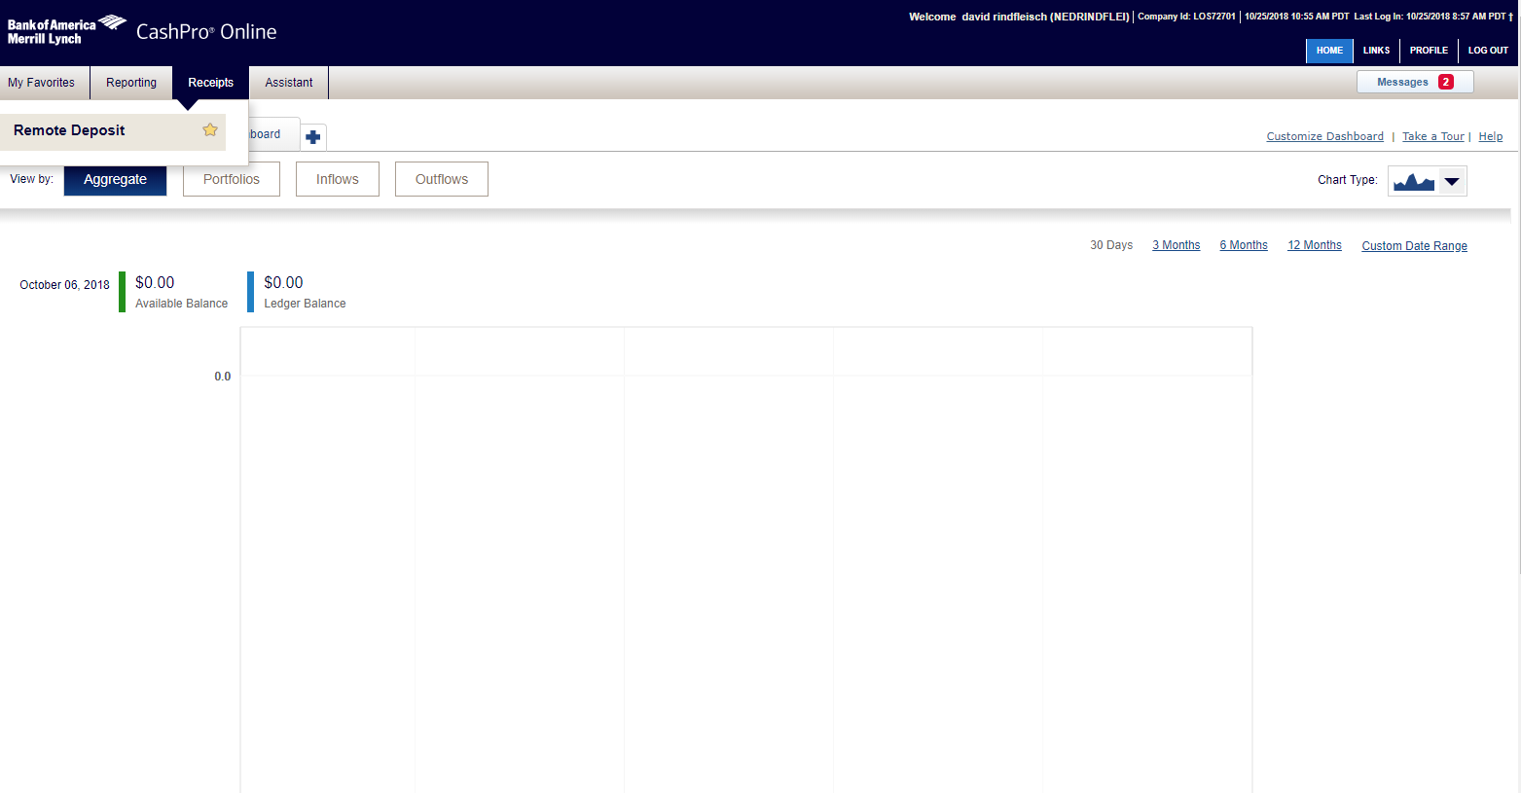

- On the next page click “Create new deposit”

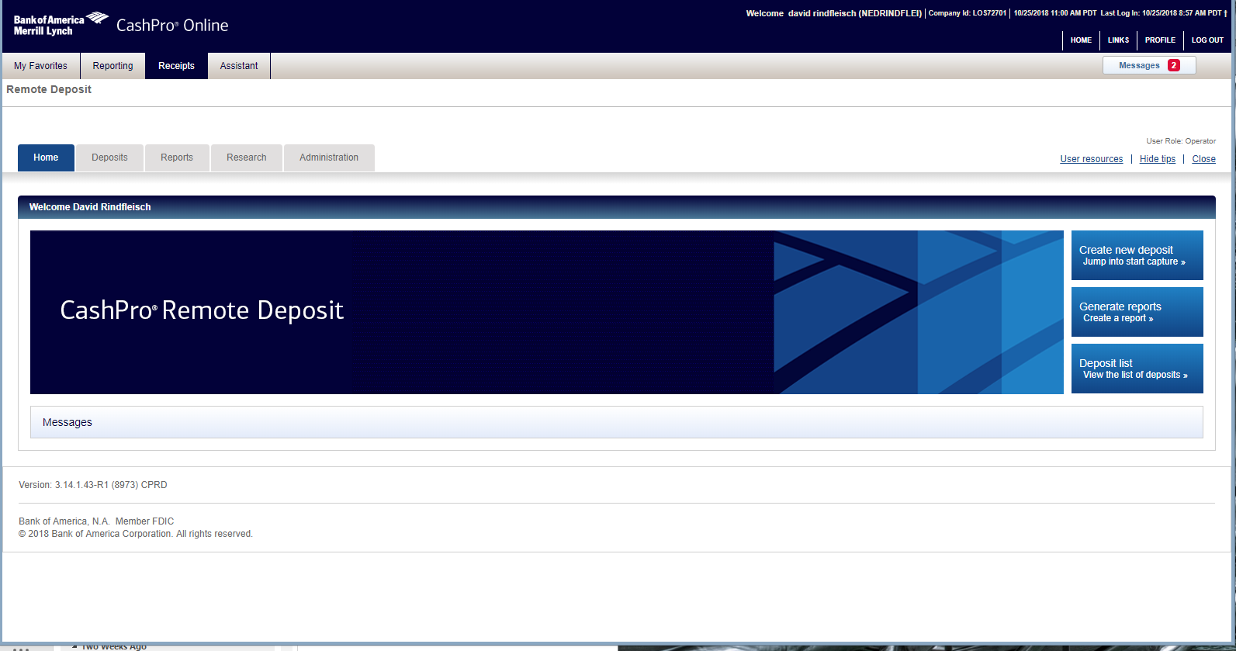

- Select the correct “Account number” from the dropdown option to process the remote deposit. Refer to RDS instructions Section 6b for remote deposit procedures.
- Enter number of checks +1 for the electronic batch slip that is automatically generated.
  - For example, if there are 10 checks, enter 11 (10+1) in the “Number of items”.

- Select “Start Capture” button. 